# ***PRACTICAL – 2***

DATE: 10/07/2024, Wednesday

## **AIM: TO STUDY DIFFERENT CATEGORY OF NETWORKS**

* Networking refers to the practice of connecting computers, devices, and other components to share resources and information.

### **TYPES OF NETWORK**

* LAN (Local Area Network)
  + A LAN is a network that spans a small geographical area, such as a single building or a campus.

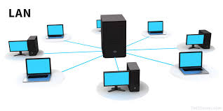

* + Devices connected to a LAN can share resources like printers, files, and internet connections.

|  |  |
| --- | --- |
| Advantages of LANs | Disadvantages of LANs |
| 1. Resource Sharing: Allows sharing of resources such as printers, files, and internet connections among connected devices. | 1. Limited Coverage: LANs typically cover a small geographic area, such as a single building or campus. |
| 2. High Speed: Provides high-speed data transfer rates within the network, improving efficiency and productivity. | 2. Cost: Setting up and maintaining LAN infrastructure can be expensive, especially for larger networks. |
| 3. Centralized Data Management: Facilitates centralized data management and backup, enhancing data security and accessibility. | 3. Complexity: Managing and troubleshooting LANs, especially as they grow in size, can be complex and require skilled IT personnel. |
| 4. Improved Collaboration: Enables easy collaboration among users by allowing shared access to documents and resources. | 4. Security Risks: LANs can be vulnerable to security breaches if proper security measures are not implemented, potentially exposing sensitive data. |
| 5. Scalability: LANs can be easily scaled by adding new devices or expanding coverage, accommodating growing organizational needs. | 5. Dependency on Hardware: Dependence on hardware components like switches, routers, and cables can lead to network disruptions if these components fail. |

* MAN (Metropolitan Area Network)

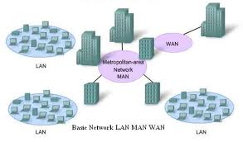

* + A Metropolitan Area Network (MAN) is a network that connects multiple LANs (Local Area Networks) within a specific geographic area, typically covering a city or a large campus. MANs provide high-speed connectivity over a larger area than LANs, facilitating efficient data exchange and resource sharing among connected LANs.

|  |  |
| --- | --- |
| Advantages of MANs | Disadvantages of MANs |
| 1. Wider Coverage: Covers a larger geographic area than LANs, typically spanning a city or metropolitan area. | 1. Cost: Setting up and maintaining MAN infrastructure can be expensive due to the need for extensive cabling and equipment. |
| 2. High Bandwidth: Provides high-speed data transfer rates suitable for connecting multiple LANs and supporting large-scale data communications. | 2. Complexity: MANs can be complex to design, implement, and manage due to their size and scale. |
| 3. Resource Sharing: Allows for efficient resource sharing among connected LANs, enhancing collaboration and productivity across a city or region. | 3. Dependency on Service Providers: MANs often rely on telecommunications service providers for connectivity, which can affect reliability and performance. |
| 4. Scalability: MANs can be scaled up to accommodate growing network needs and increased data traffic within a metropolitan area. | 4. Security Challenges: Security management across a large area can be challenging, requiring robust security measures to protect data and resources. |
| 5. Business Connectivity: Supports connectivity for businesses, educational institutions, government offices, and other entities across a city, fostering economic growth and development. | 5. Regulatory and Compliance: Compliance with local regulations and standards may pose challenges, especially when integrating different network technologies and service providers. |

* WAN (Wide Area Network)

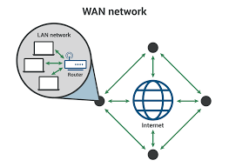

* + A WAN is a network that covers a broad area, such as multiple cities or countries.
  + WANs often connect LANs over long distances using leased lines, satellites, or other communication technologies.

|  |  |
| --- | --- |
| Advantages of WANs | Disadvantages of WANs |
| 1. Wide Geographic Coverage: WANs can connect devices and networks across vast geographical areas, such as between different cities, countries, or continents. | 1. Cost: Setting up and maintaining WAN infrastructure can be expensive due to equipment, leased lines, and operational costs. |
| 2. Scalability: WANs can scale easily to accommodate growth in users, devices, and data traffic across large distances. | 2. Complexity: WANs are complex to design, implement, and manage, requiring skilled IT personnel and comprehensive planning. |
| 3. Global Connectivity: Facilitates global communication and collaboration among remote offices, branches, and users, enhancing business operations and productivity. | 3. Performance: Performance can be affected by factors such as distance, network congestion, and the quality of service from service providers. |
| 4. Resource Sharing: Enables efficient sharing of resources, applications, and data across distributed locations, improving efficiency and reducing costs. | 4. Security Risks: WANs are more susceptible to security threats, including data breaches, unauthorized access, and malware attacks, necessitating robust security measures. |
| 5. Flexibility: Supports diverse network technologies and protocols, allowing organizations to choose the most suitable solutions for their specific requirements and applications. | 5. Dependency on Service Providers: WAN performance and reliability depend heavily on service providers, with potential service disruptions impacting business continuity. |

* PAN (Personal Area Network)

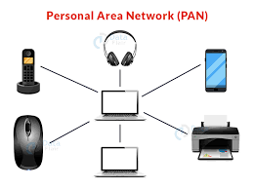

* + A PAN is a network that is used for communication among devices within the range of an individual person, typically within a few meters.
  + Bluetooth and infrared connections are examples of PAN technologies.

|  |  |
| --- | --- |
| Advantages of PANs | Disadvantages of PANs |
| 1. Personal Connectivity: Provides connectivity for personal devices within a short range, typically within a few meters. | 1. Limited Range: PANs have a limited coverage area, restricting device connectivity to a short distance from each other. |
| 2. Ease of Use: Simple to set up and use, often using wireless technologies like Bluetooth or Infrared (IR) for device communication. | 2. Interference: Wireless PANs can experience interference from other wireless devices operating on the same frequencies. |
| 3. Flexibility: Supports various types of devices, including smartphones, tablets, laptops, wearable devices, and IoT devices, enabling seamless communication and data sharing. | 3. Security Concerns: Data transmitted over wireless PANs may be susceptible to interception or unauthorized access, requiring encryption and security measures. |
| 4. Mobility: Enables device mobility within the PAN coverage area, allowing users to move freely while maintaining connectivity. | 4. Device Compatibility: Devices within a PAN may require compatibility with specific wireless protocols or standards for seamless communication. |
| 5. Personalization: Allows individuals to connect their personal devices and share information, files, and media without requiring a broader network infrastructure. | 5. Limited Scalability: PANs are designed for personal use and may not scale well to accommodate multiple users or extensive network expansion. |

* WLAN (Wireless Local Area Network)

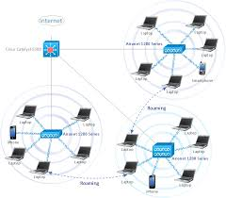

* + A WLAN is a type of LAN that uses wireless communication technology, such as Wi-Fi, to connect devices within a limited area.
  + WLANs provide flexibility and mobility for devices to connect to the network without the need for physical cables.

|  |  |
| --- | --- |
| Advantages of WLANs | Disadvantages of WLANs |
| 1. Mobility: Provides wireless connectivity, allowing devices to connect and communicate without physical cables, enhancing mobility and flexibility. | 1. Interference: WLANs can experience interference from other wireless devices, physical obstacles, or environmental factors, affecting signal quality and performance. |
| 2. Convenience: Easy to set up and expand, providing flexibility in network deployment and allowing users to connect from various locations within the coverage area. | 2. Security Risks: Wireless networks are susceptible to security threats such as unauthorized access, eavesdropping, and data interception, requiring robust security measures like encryption and authentication. |
| 3. Scalability: Supports scalable network expansion to accommodate additional devices and users, making WLANs suitable for growing organizations and dynamic environments. | 3. Range Limitation: WLAN coverage is limited compared to wired networks, requiring careful planning and additional access points (APs) to cover larger areas. |
| 4. Cost-effective Deployment: Reduces the need for extensive cabling infrastructure, lowering installation costs and simplifying network maintenance. | 4. Bandwidth Limitations: WLANs may experience bandwidth limitations, especially in high-density environments with multiple devices competing for network resources. |
| 5. Productivity: Facilitates seamless access to network resources, applications, and services, enhancing productivity and collaboration among users. | 5. Performance Variability: Performance can vary based on factors like distance from the access point, network load, and signal strength, impacting user experience and application responsiveness. |

Date of Submission: Sign:

________________________ Mr. Jigar Patel